# MapReduce with AWS

### 1). Create S3 Bucket

This bucket is used to store input log files and output data

### 2). Create EMR cluster

Will create 2 EC2 instances, one works as a master node, the other works as a slave node.

The default configuration will install:

Hadoop

Tez

Hive

Pig

Ganglia

Hue

### 3) Process Sample Data by Running a Hive Script

Step: a unit of work in Amazon EMR which contains one or more Hadoop jobs.

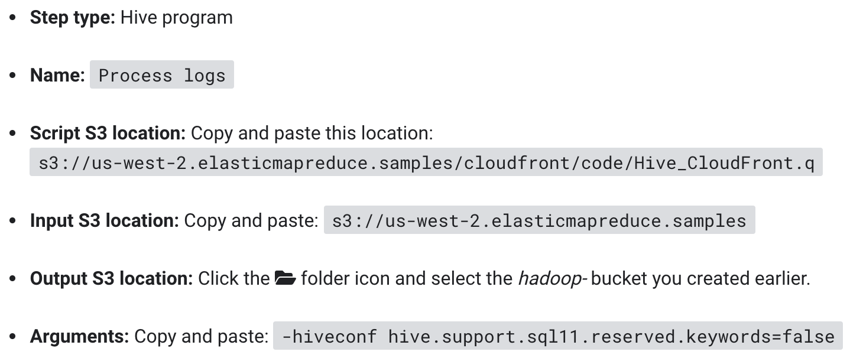

The step will:

1. Create a Table
2. Read data from the input S3 bucket
3. Parse the date using the Regular Expression Serializer/Deserializer
4. Write the parsed result to the Table.
5. Execute a HiveQL query against the Table.
6. Write the query results to the output S3 bucket.

Logging initialized using configuration in file:/etc/hive/conf.dist/hive-log4j2.properties Async: false

OK

Time taken: 5.747 seconds

Query ID = hadoop_20181013152626_387a901b-b09b-4b2e-ae71-633fa49ee745

Total jobs = 1

Launching Job 1 out of 1

Status: Running (Executing on YARN cluster with App id application_1539443941672_0001)

Map 1: -/- Reducer 2: 0/1

Map 1: -/- Reducer 2: 0/1

Map 1: 0/1 Reducer 2: 0/1

Map 1: 0/1 Reducer 2: 0/1

Map 1: 0(+1)/1 Reducer 2: 0/1

Map 1: 0(+1)/1 Reducer 2: 0/1

Map 1: 0(+1)/1 Reducer 2: 0/1

Map 1: 0(+1)/1 Reducer 2: 0/1

Map 1: 0(+1)/1 Reducer 2: 0/1

Map 1: 0(+1)/1 Reducer 2: 0/1

Map 1: 0(+1)/1 Reducer 2: 0/1

Map 1: 0(+1)/1 Reducer 2: 0/1

Map 1: 0(+1)/1 Reducer 2: 0/1

Map 1: 1/1 Reducer 2: 0/1

Map 1: 1/1 Reducer 2: 0(+1)/1

Map 1: 1/1 Reducer 2: 1/1

Moving data to directory s3://hadoop-365/os_requests

OK

Time taken: 40.627 seconds

Command exiting with ret '0'

### 4) View the result in the output S3 bucket

